

Corporate Internship Programme 2025–27
AI DEMONSTRATION AND USE EVIDENCE BUNDLE
ON
PRIVATE BANKING SECTOR ANALYSIS

Student Name | Tanya Grover
Programme & Batch | PGDMFM | Batch 2025–2027
Organization Name | Aditya Birla Capital
Industry / Sector | Financial Services — Equity Research & Wealth Management (Client Advisory)
Internship Duration | April 2026 – June 2026
Faculty Supervisor | Dr. Shallu Batra
Organizational Supervisor | Mr. Nikesh Ruparel
Date of Submission | June 11, 2026

AI DEMONSTRATION AND USE EVIDENCE BUNDLE
INTRODUCTION
During my internship at Aditya Birla Capital as an Equity Research Intern, I worked on a project titled "Private Banking Sector Analysis." The project involved the construction of a Private Banking Index, identification of Value Picks and Growth Picks, portfolio construction, NAV calculation, and technical analysis of selected banking stocks.
As the project involved repetitive calculations, data analysis, and report preparation, I explored the use of Artificial Intelligence and automation tools to improve efficiency and reduce manual effort. The objective was not to replace financial analysis but to support the research process through faster calculations, structured reporting, and automated workflows.
Three different approaches were explored during the internship:
- Custom GPT-based analysis
- Python-based automation
- Make.com workflow automation
These approaches were tested using actual project data related to the private banking sector.
AI INTEGRATION THROUGH CUSTOM GPT
The first approach involved the development of a Custom GPT specifically designed for the Private Banking Sector Analysis project.
The Custom GPT was configured using the methodology developed during the internship, including:
• Private Banking Index calculation framework
• Value Picks methodology
• Growth Picks methodology
• NAV calculation process
• Portfolio performance analysis
• Wealth management reporting format
The GPT was tested using actual banking sector data. After uploading the data, the system was able to generate:
• Private Banking Index summaries
• Top and bottom contributors
• Value Picks
• Growth Picks
• NAV summaries
• Portfolio performance reports
• Wealth management reports
The outputs generated by the GPT were compared with manual calculations to verify consistency and accuracy.
This approach significantly reduced the time required for preparing analytical reports and helped organize the output into a structured format.
(Screenshot Reference: Custom GPT Interface and Generated Reports)
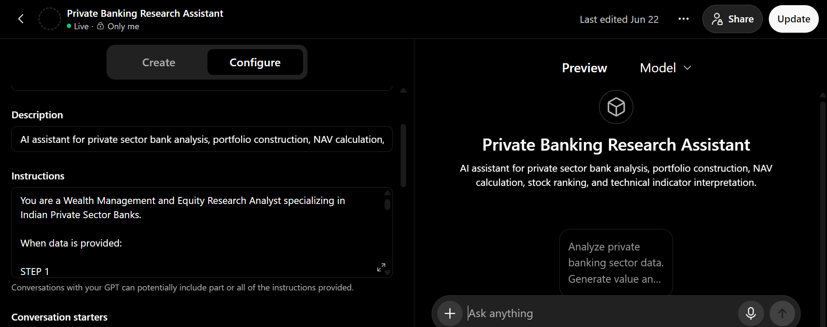
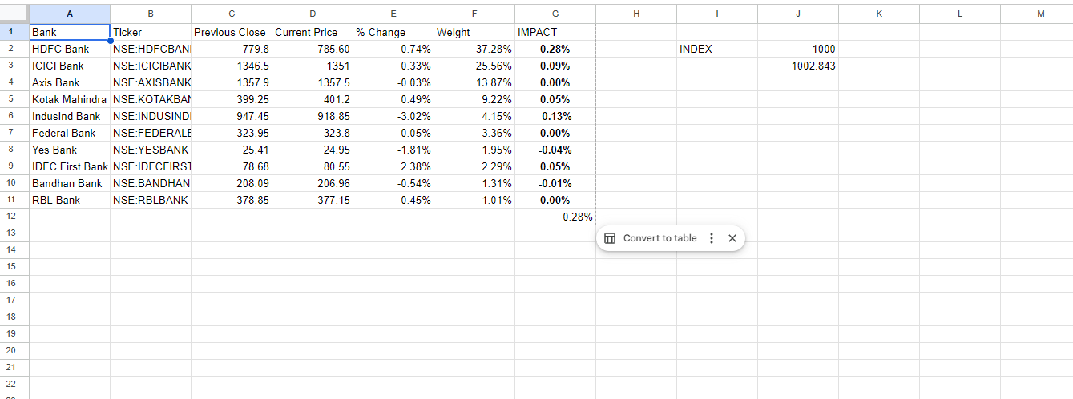

AI INTEGRATION THROUGH PYTHON
The second approach involved the use of Python for automating calculations and portfolio analysis.
Python scripts were developed to automate:
• Retrieval of stock prices
• Portfolio valuation
• NAV calculation
• Portfolio return calculation
• Index calculation
Financial data was collected through market data sources and processed automatically using Python.
This approach demonstrated that repetitive calculations could be automated without requiring manual spreadsheet updates. The Python workflow also reduced calculation errors and improved efficiency when handling multiple stocks simultaneously.
The Python-based system showed how portfolio monitoring could be performed through a repeatable and scalable process.
(Screenshot Reference: Python Code and Output Results)
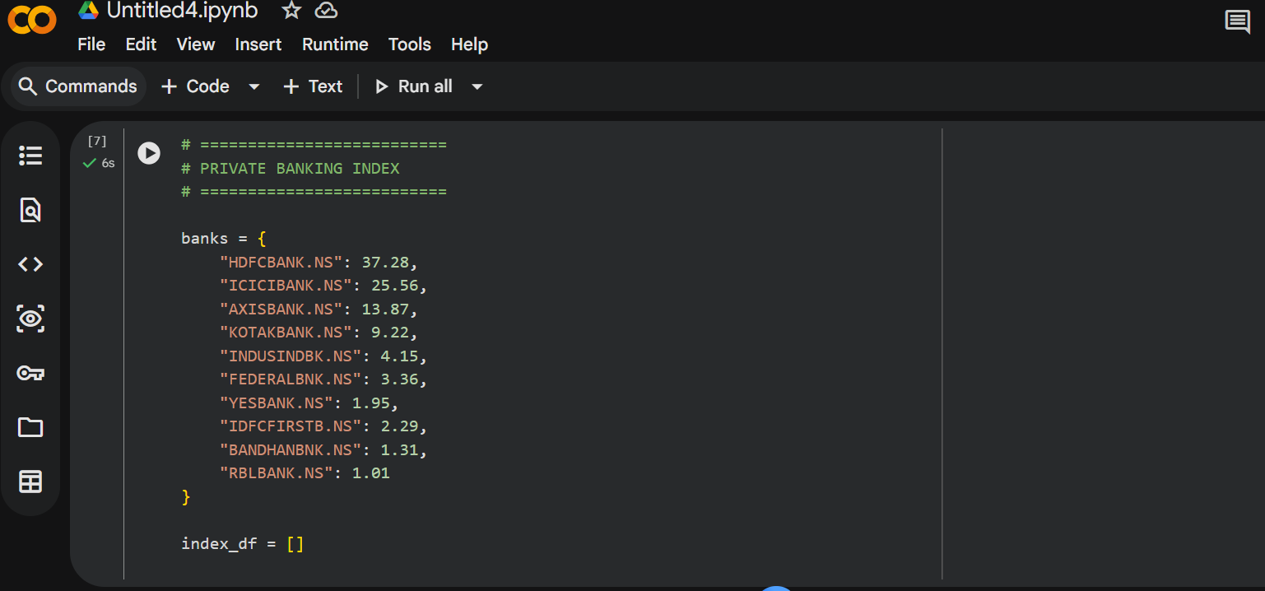

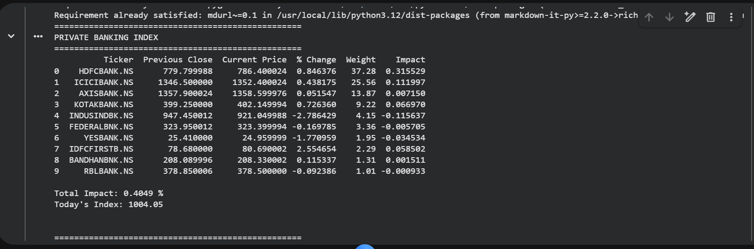

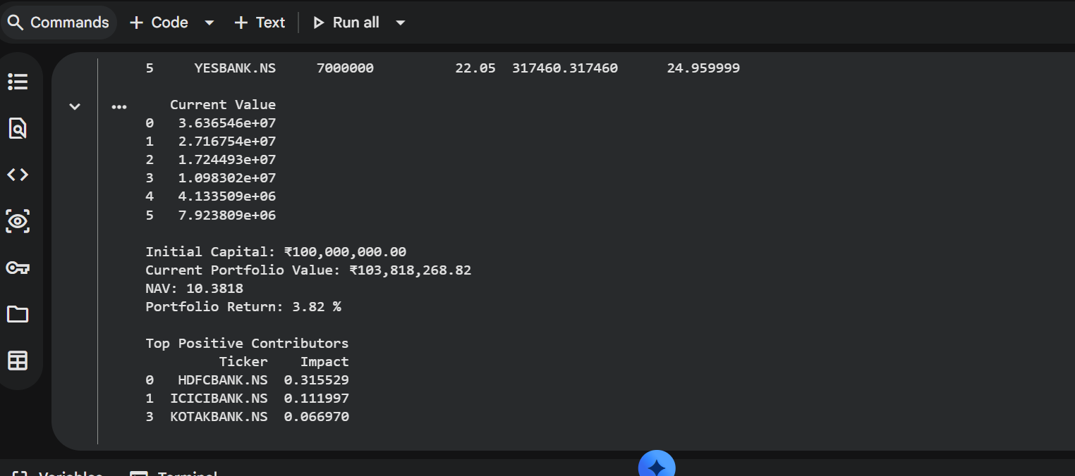

AI INTEGRATION THROUGH MAKE.COM
The third approach focused on workflow automation using Make.com.
The objective was to create a fully automated system capable of:
Google Sheets → OpenAI → Automated Analysis → Report Generation
The proposed workflow involved:
Step 1:
Collect updated banking data from Google Sheets.
Step 2:
Transfer the data automatically to OpenAI.
Step 3:
Generate Private Banking Index analysis, Value Picks, Growth Picks, and NAV reports.
Step 4:
Produce structured outputs without manual intervention.
As part of the implementation process, Google Sheets was successfully connected to Make.com. The banking data sheet containing stock prices, weights, index calculations, and portfolio information was successfully retrieved through the workflow.
An OpenAI API connection was also created and configured successfully.
However, the automation could not be completed because the OpenAI API account required billing credits for execution. Although an API key was generated successfully and the connection was established, the workflow could not proceed beyond the testing stage due to billing restrictions.
Despite this limitation, the workflow demonstrated the feasibility of creating a fully automated reporting system.
If API billing access had been available, the entire process could have been automated from data collection to report generation.
(Screenshot Reference: Make.com Workflow, Google Sheets Integration, OpenAI API Connection, Billing Error)
Section 3.1: Deployment Level Achieved
Deployment Level Achieved: Level 1 – Demonstrated in Context
The AI solution achieved Level 1 deployment. The solution was successfully developed, tested, and demonstrated using actual project data related to the Private Banking Sector Analysis project.
The solution was reviewed within the internship context but was not independently used by other employees. Therefore, Level 2 and Level 3 deployment were not achieved.
Section 3.2: How the Solution Was Demonstrated and Deployed
The AI solution was demonstrated during the internship using actual banking sector data. The demonstration included the Custom GPT workflow, Python automation process, and Make.com automation framework.
The generated outputs included index calculations, stock selection reports, portfolio analysis, and NAV summaries.
The results were reviewed and compared with manual calculations to evaluate accuracy and practical usefulness. The demonstration showed that AI-assisted workflows can reduce manual effort and improve the efficiency of financial analysis and reporting.
Section 4.1: Who Saw the Solution
Name: Mr. Nikesh Ruparel
Role: Corporate Mentor
The AI solution was demonstrated to Mr. Nikesh Ruparel during the internship. The demonstration included the Custom GPT analysis framework, Python automation workflow, and Make.com automation design.
Actual project data was used during the demonstration. The generated outputs and workflow design were reviewed and discussed as part of the internship project.
The solution remained at the demonstration stage during the internship period and was not independently operated by other users.
FELLOW INTERNS
In addition to the Corporate Mentor, fellow interns working on related financial analysis projects also reviewed the outputs generated through the solution.
The AI-generated reports, index summaries, and portfolio analysis outputs were discussed informally during internship interactions. Fellow interns compared the outputs with traditional spreadsheet-based analysis and observed the potential benefits of automation and structured reporting.
No colleague independently operated or deployed the solution. The engagement remained limited to observation, discussion, and feedback during the internship period.
REAL DATA USED
The solution was tested using actual project data collected for the Private Banking Sector Analysis project. The data included selected private sector banking stocks, portfolio allocations, index calculations, stock performance information, and NAV calculations.
This ensured that the demonstration reflected a realistic business use case rather than a hypothetical example.
DEMONSTRATION SETTING
The demonstrations were conducted during internship project discussions and review interactions. The generated outputs, analytical reports, and workflow designs were presented and discussed as part of the project evaluation process.
The demonstrations focused on showing how AI and automation tools could reduce manual effort while maintaining consistency in analysis and reporting.
SUMMARY
The AI solution successfully demonstrated how Custom GPTs, Python, Google Sheets, and workflow automation tools can support equity research and wealth management activities. The project showed the potential for automating repetitive calculations, generating structured reports, and improving analytical efficiency.
Although the solution remained at the demonstration stage during the internship, it provided a practical proof of concept for future automation and AI-supported financial analysis workflows.

